Forum on Women Candidates’ Participation in the 2017 PNG Election

17th – 18th August 2017
National Aquatic Centre, Taurama, Port Moresby

REPORT

“Women need to start rocking the boat”

Organised by United Nations Development Programme Papua New Guinea

Table of Contents

1. Introduction 2
2. Context 2
3. Women Candidates Forum 2017 4
4. Forum Discussions: Reflections from candidates 4
5. Forum Discussions: summary 8
Legal and institutional issues 8
Role of the political parties 10
Role of the Media 11
6. Recommended priority activities 12
Priorities for action 12
Small groups: Recommended activities 14
7. Conclusions and next steps 17
Annex 1: Women Candidates Forum Outcomes Statement 18
Annex 2: UNDP/NDI Electoral Cycle Approach to Promoting Women through Political Parties 21
Annex 3: Draft UN Women Theory of Change: Women’s Political Participation & Leadership 22

REPORT
Forum on Women Candidates’ Participation in the 2017 PNG Election
17th – 18th August 2017

Introduction
A National Forum on Women Candidates’ Participation in the 2017 PNG Election was organised by UNDP-PNG on 17 and 18 August 2017. Close to fifty participants attended the Forum, from government organisations, private sector, NGOs, academia and as concerned citizens. Importantly, 6 of the women candidates that contested the 2017 National Elections also participated.
The objective of the Forum was to gather views on how best to address the reality that no women were elected during the June 2017 general elections to sit in the 10th Parliament of PNG. The Forum provided an opportunity for participants to reflect upon the conduct of the recent elections, in order to assess what strategies and approaches worked and did not work so well for women candidates, as well as to propose innovative activities that could be implemented over the coming five years to ensure women’s presence in the national parliament after the 2022 elections.

Context
In the June 2017 National Elections, 167 women candidates put their names forward to be elected as national legislators. Although a small cohort – only 167 out of a total of 3332 candidate overall – this number represents an increase from 3.9% women candidates in 2012 to 4.9% in 2017. Despite some very successful campaigning by women in 2017, only a handful reached the later stages of the process, with three women reaching the top three before being eliminated. Consequently, the National Parliament of PNG now has no women MPs for the next five years. PNG has joined only four other countries in the world – Vanuatu, FSM, Qatar and Yemen – as having no women MPs at all.
Diagram 1: Number of female candidates contesting National Elections
compared with male candidates 1977-2012
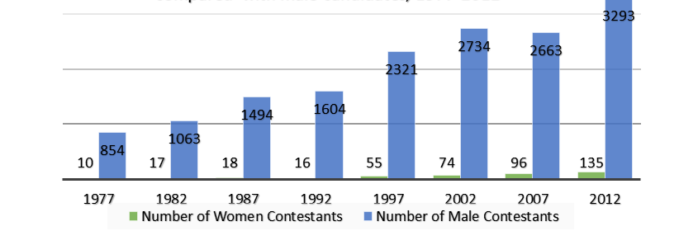
Since PNG’s Independence in 1975, the number of national female MPs has varied from zero in the 1987 and 1992 elections (and the present), to the high point of three MPs in the 1977 and 2012 elections. In 1997, there were only two women MPs, and then one women MP elected for two consecutive terms of Parliament, in 2002 and 2007. Only seven women MPs have ever been elected to PNG’s national parliament. These poor results are in part due to the very low percentage of women contesting elections (see Diagram 1 above). On average, in the past three elections (2002, 2007 & 2012), one female contested a seat for every 28 male contestants.
Historically, even when female candidates contested, only a minority were endorsed by a political party. Under PNG’s Organic Law on Integrity of Political Parties and Candidates (OLIPPAC), political parties are encouraged to endorse female candidates (for which they receive cash incentives), yet they have tended to endorse male candidates more often, with the majority of female contestants ran as independent candidates. Notably however, in this election, more women were endorsed by political parties (61 women) and it was notable that most of the highest-placed women candidates had political party support.
At the local level, women’s political participation also remains a challenge and what representation there is has often been tokenistic. Notably, PNG’s Organic Law on Provincial and Local-Level Governments 1995 provides for one nominated women’s representative on each Provincial Assembly and each Urban LLG and two such representatives on Rural LLG district and ward councils. It also provides for women’s representatives on the local Joint District Planning and Budget Priorities Committee and for the inclusion of a women’s representative on District Development Authority (DDA) boards. However, implementation of these measures has been slow and only limited attention has been given to who these women representatives are and how effectively they are participating and influencing decisions and policies.
Considerable work has been done over the years to support women’s political participation in PNG – most notably, the campaign in 2011/12 to advocate for reserved seats for women in the national parliament, and ad hoc campaign trainnig for women carried out initially by women-led NGOs (espcially PNG Women in Politics and the National Council of Women) and more recentlty by development partners – but these efforts have had varying success. There has also been considerable research undertaken by UNDP, UN Women, NRI, INA, UPNG, SSGM-ANU, CDI-ANU, and others to understand why women are not getting elected across the Pacific, and in PNG in particular. In 2016, a Pacific regional study consolidated this research on women’s leadership and a number of critical challenges were highlighted, including:
- Work to support the enabling environment through law reform has not involved enough male change makers and has also failed to build public support;
- Insufficient work has been undertaken at sub-national levels to build women’s capacities;
- Training candidates has potential but has tended to target the wrong women and has usually been provided too late;
- An electoral-cycle approach has not been applied, so that support is ad hoc and provided too late; and
- Insufficient investment has been made in building coalitions for change.

Women Candidates Forum 2017
Recognising the inherent vaue of incuding women’s voices in PNG’s national legislature and other elected local assemblies and concerned about that no women were elected at all to the 10th PNG Parliament, UNDP decided to build on its previous efforts to support women’s political participation by organising a Forum to draw attention to the issue of women’s lack of representation in advance of the first session of the 10th Parliament, scheduled to open in the week following the Forum. The Forum brought together women candidates, influential stakeholders and concerned citizens from across different sectors to reflect upon women’s participation in the recent general election. The Forum was designed as a pratical, interactive meeting that will enable participants to share their reflections on the past, as well as to identify strategies on how to most effectively move forwardto increase and stregthen women’s representation within Parliament over the coming five years in order to ensure women’s presence in the national parliament after the 2022 elections.
In advance of the Forum, UNDP and UN Women circulated a PNG Women Candidates Survey on the Facebook “PNG Women in Leadership” Page on 15 August 2017 that was intended to focus respondents on diagnosing the challenges women face and finding responses to addres them. The survey asked respondents to identify what they felt contribute to the good performance of candidates, and what the key challenges were that were faced by women candidates. It then asked respondents to suggest actions that could be taken by Government, Parliament and civil society to support women’s political participation. A summary of the Survey results can be found on the PNG Women in Leadership Facebook page, and on the PacWIP publications page.

Forum Discussions: Reflections from candidates
At the outset of the Forum, the facilitator highlighted that “pos-election is pre-election”. There are 5 years until the 2022 elections and it is imperative to immeditely start strategising and preparing women for the next elections. With this in mind, the Forum opened with a summary of critial issues for women candidates that have already been idenified following previous elections and could be built upon during the Forum discussions. Specifically, a 2007 Diagnostic Assessment of Women Candidates’ Experiences and a 2012 Review of the Experiences of Women Candidaes in the 2012 Electons were undertaken following the 2007 election and the 2012 elections respectively and each identified a number of critical challenges facing women, as well as collecting together recommendations for action to address these challenges. The discussions during the Forum attempted to build on these lessons learned.
In order to ensure that the Forum’s discussions were grounded in practical realities, the first session showcased the experienes of 4 women candidates themselves, Other candidates also in atendance also shared their experiences, but the four women on the first panel discussion focusing on “setting the scene”, with reflections from candidates in 2 coastal electorates and 2 Highlands elecctorates bringing out the complex issues facing women across the country.
Rufina Peter – Candidate for the Central Regional Seat, 2017 Election
Reasons for contesting for the 2017 elections is because she wants; i) to scale out CPD model in Central Province; ii) establish political performance bench mark, because it is not clear; iii) Bringing a different perspective to the urgency of issues in Central Province; iv). When in office to have a say in funding, and; v) have share with the stakeholders.
Challenges:
- She shared that she was not prepared for the election. She started late in 2016.
- Coordinators in communities were not established
- She saw that the environment was conducive because candidates did not have money ‘dry campaign’.
- Party supported with posters only. The issue it that it was not timely to distribute the posters (posters were sent to her late).
- She had one vehicle to cover Central Regional. She negotiate for a hire car.
- She had four people in her team. Two female and two male.
- She had financial support from family, friends, and individuals.
Campaign Strategy
- Campaign message is important. She did awareness message on corruption, and the need to do something and impact Central. She also talked about why she is the best candidate in Central Province.
- Strategy – she had her profile on facebook. Detailed profile setting out experience (with government, NGOs etc). She also shared experiences that she had in the communities- project formulation to implementation.
- From her experience, people do not want to see ‘middlemen’ in development, because these middlemen lead to mismanagement.
- Success factors include base vote is critical. She was able to secure 42 percent from her District. Challenge was transport, helicopter is needed to travel to her District. Kairulu Hiri has the largest population.
- Also understanding of the LPV system is really important. In every campaign, the message was that we should have “10 percent of women in Parliament”. However, it is a challenge because she really cannot do that at the regional level.
Recommendations
- There is a need for comprehensiveness – assistance package for women
- Awareness on important issues, LPV etc
- Women candidates’ preparedness, 3-5 years.
- Legal reform – OLPPAC – women need financial support, reserved seats must happen, and the institutional strengthening of the Electoral Commission.
- Biggest challenge is finance
- Money was played in the 11th hour. If police etc can do their job, women’s number will improve.
- 2018 LLG elections, she is willing to talk to women at this level.
- Parliamentary support work. Therefore, acknowledge ‘Practise Parliament’.
- People wanted to hear her speak, to see if she can stand as woman. That will demonstrate that women can stand in Parliament. Therefore, women need to go down to the people and talk to them.
Kessy Sawang – Rai Coast Open candidate, 2017 elections
She finished 3rd place in her electorate. From count 1 -25, she was running second place, and from count 22 -25, she came fourth. Rai Coast literacy is low and is a rural area. She is a first time candidate, and one of the first women from her District to contest the National Elections. She termed her experiences as her “political journey” that she undertook for 10 months. Even though she lost she feels she was successful because she changed the mindset of voters to believe that women can be good leaders.
Challenges
- Getting the confidence/ trust of the people. Because their view is that leadership is for men. Therefore the mindset of the people need to be changed.
- Campaign was aggressive, where men say dirty things about women.
- Underestimation of leadership. Therefore, han mak is a challenge. She lived in city a lot. So she did a lot of awareness, on government functions etc
- Lack of economic resources. She was able to cover only 2 out of 4 LLGs.
- Hiring a chopper is expensive at K15, 000 per hour.
- Women did not vote freely. The Electoral Commission did not provide security. Voter were intimidated by male candidates. Electoral commission should look into the security to give women a fair play.
- Male candidates use money, not the women. The “kaikai man” – they then use the money and vote for other candidates.
- The people want the candidate to live with them. She got most votes where she walked. So you have to be with the people on the ground, it is what you can do
- Fighting a battle against previous women MPs, because last 3 were not seen to stand for women – some voters assessed her based on their previous performance.
Campaign Strategies
- Have plan A, B, and C. First target the women.
- Needed to change the cultural mindset – therefore she targeted the youths, and the message is to “let a woman lead the change”. She brought together youth because they are more educated and active. She ran workshops on women leadership, and youths’ message was that “we trusted father for 42 years, let’s try our mother”.
- Look at political parties over the 5 years, fundraising efforts, work with political parties, establishment in rural areas – she walked 7 weeks.
- She ran “a grassroots funding campaign”. It 4 million women donate K1, then 1 woman candidate can use this to run her campaign.
- She used strategy to get a lot of male support. There were big crowds. She approached other candidates, building partnership. So she targeted potential winners. For examples, Jerry Singerok, James Yali, and Peter Yama. Sitting members have influence. With this meetings, the male leaders campaigned for her. Therefore, it is good to work with the men, because they decide the votes.
- 2 strategies applied;
  - Campaign strategy: campaign managers, tailored demography, they made it simple. For example: money and development
  - Education strategy – awareness is important
Recommendations
- Critical to immediately start “grassroots fundraising” for women candidates.
- It is important to build skills and capacity of women candidates. Build/train their capacity. This will be used to convince people to vote for them.
- Asking the right questions is important. Providing alternative leadership
- Look at policies and ways to assist women.
- Base vote. Family, area where she came from gave her undivided support, a commitment was made.
- Recommend continuing ‘Practice Parliament’ and to start early, not just before elections.
Veronica Waieng - candidate for the North Waghi Open, 2017 elections
She started her journey in 2015. She went home, brought together the elders and asked them to support her. Therefore, she got her endorsement from her tribe to contest in the 2017 elections. This experience is “make or break”. They say about politics, once you get it, it is only the start. She will run again, but the experience has changed her perspective.
Campaign Strategies
- She tried to focus on policy - advocating for zero tolerance on corruption.
- She undertook targeted awareness in North Waghi open electorate in order to increase the block vote she anticipated in her home area
Challenges
- Challenge from 2 of her own relatives, which split her vote. She realised that there was a deliberate strategy of vote-splitting which meant LPV didn’t work for her
- She anticipated Highlands block voting would go in her favour in her own village, others co-opted her vote with their tactics
- Allegations of cash distributed by other candidates - money politics play decisive role where the box and the ballot papers are
- She heard of youths intimidating voters - people did not really vote and stood helpless - they used the term ‘yumi go lo box’ to refer to polling place.
- Security need to be improved.
- She had Party endorsement, but still not enough concrete support.
- In her electorate, voting was not so bad – but in other areas, the process was hijacked.
Recommendations
- Get women to rally behind women – still a lot of work to do in that area
- Planning goes down to the last 24 hours.
- How to raise funds? Need to start now.
- Need to get the message across to each voter - presence in the community is important.
- Must be firm, not soft, because men will push you around.
- Mock parliament was good, helped her to do last minute change to her plan. She got the only help from UNDP.
Monica - Candidate for Laiagap Porgera Open, 2017 elections
Her experience was extremely difficult, as she was a rare woman candidate in the Highlands of Enga Province. Where in other electorates people might respect women candidates, in Enga it is a very unfair game. There is a need for a lot of work to be done in Enga – development partners need to take action because talking will not make a difference. People need to come and work in the more difficult provinces for women.
Challenges
- There was no support from men – for instance, no men worked to stop tribal fighting between people - many tribal fights in her electorate - your own blood line will not respect you as a woman vecause the perception is that you belong to the garden etc.
- Governor did not hold hands with others to work together.
- Voting situations in her electorate was dire – ballot boxes hijacked
- Money politics was rampant - need to have K10 million to run for elections
Recommendations
- All need to work together to set up a committee and go into the most difficult places where there is a need for improvement - Enga Province is one of those
- UN and UNDP need to go into Enga, if we want serious improvement

Comments/Feedback
Following the women’s presentations, plenary discussions followed. During these discussions, a number of issues were identified which were common across candidates’ experiences, namely:
- Political party support: Only 61 out of 167 candidates were endorsed by political parties. Party candidates tended to do better than independents, but even those women endorsed by parties didn’t always receive sufficient or timely support from their party;
- Electoral roll & organisation of elections: Challenges with the conduct of the elections were numerous, including voters left off the roll, allegations of vote-buying, vote-rigging and voter intimidation, and allegations of miscounting of votes, for example. Security was a critical issue for women voters and candidates;
- Financial challenges: Women repeatedly raised campaign financing as a critical issues undermining their ability to get their message out but also to visit constituencies, which was identified as a key way for getting voter support;
- Patriarchy/culture: Cultural issues were raised repeatedly as an issue, with women reporting that voters in their area didn’t believe that women could be effective leaders and/or that their place was in the home. Changing voter perceptions of women’s capabilities was identified as crucial to women’s success;

Forum Discussions: summary
Following the discussions of women candidates’ experiences, there were two panel discussions focused on critical areas that were identified by the organised as critical to women candidates’ success, namely, legal and institutional issues and political parties. These panels were led by 2-3 experts and followed by plenary discussions.

Legal and institutional issues
This panel was designed to reflect upon law reform and institutional issues that could be addressed to promote women’s political participation. It focused primarily on temporary special measures to promote women in parliament. Notably, on the morning the Forum opened, one of the participants reported that the PM had publicly stated at a breakfast meeting earlier in the day that he was open to reconsidering the 2012 proposal to reserve 22 seats in the Parliament for women only. This was reported in the media the following day (see the photo to the right).

Panellists Dr Betty Lovai, an academic, and Ms Florence XXXXX, the Executive Director of the Employees Association, explained the previous options for implementing reserved seats for women that have been proposed in PNG, which both were involved in progressing:
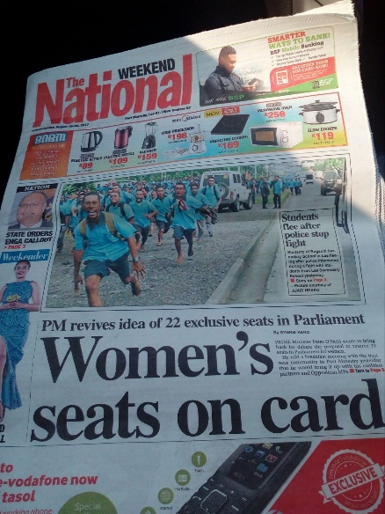
- 2 appointed seats for women: In 2008, a proposal was progressed to nominate 1 women MP to parliament, using Art.102 of the PNG Constitution. This section allows for 2 appointed 2 seats, to enable minority representation in Parliament. However, the seats do not have all of the privileges of elected members, with voting rights restricted. In 2008, then-PM Somare proposed using this power to appoint a woman. A selection committee was set up, with 12 members. A call for nominations was issued, and 78 women submitted their applications. The committee vetted these applications and compiled a short-list of 10 women who were then interviewed by the committee. Six women’s names were then selected and given to the Government, who were to choose 3 women whose names would be submitted to the Parliament, who would then vote on 1 women to be appointed by the PM. However, in the final stages of the process, the names were released and some in the women’s movement baulked at the nominees. Additionally, concerns were raised about a committee outside parliament being used to develop the list of candidates. The Opposition then withdrew from the bipartisan process and everything stalled. A lesson learned is that some form of parliamentary process should be developed to propose women nominees if s.102 is used again;
- 22 elected seats for women: When the appointed seats proposal stalled, campaigners – led at the time by Dame Carol Kidu, the only women MP – moved on to advocating for the creation of 22 seats to be reserved for women. This campaign was almost successful, with a Bill passed in 2012 to amend Art.101 of the Constitution to allow such reserved seats to be implemented. However, a second Bill to amend the Organic Law on Provincial and Local Level Government failed to pass and the creation of the provincial seats never progressed. To address this, UNDP’s Elections Advisor, My Ray Kennedy, advised that consideration could be given to using Art.22 of the Constitution to call on the Government and the courts to take action to implement s.101 without further legislation. In any case, based on the PM’s earlier statement in support of reserved seats, the old amendment Bill could be revived and tabled again for enactment in advance of 2022.

Comments/feedback
- Participants generally supported the need to start pushing again both for appointed and reserved seats. The appointed seats could fill the current vacuum in the 10th Parliament, and the reserved seats could then be put in place in time for the 2022 national elections;
- One challenge will be the lack of an obvious political champion for the TSM push. Last time, Dame Carol Kidu was an active and vocal advocate for both TSM options, but there is no Minister for Women and it is not clear who can lead. That said, the PM himself may be a useful ally. It will also be important to encourage bipartisan support. Participants could work with their political parties to get their support for TSM;
- Ongoing challenge of how to unite the women’s movement in support of these options. The campaign was weakened when the 3 women MPs elected in 2012 came out against TSM and the NCW has also become inactive since then. Need to start re-engaging with women’s groups across the country;
- Will also be critical to change mindsets across the country to create a critical mass of supporters for TSM. Should develop a coalition across the public sector in support – there are already over 12,000 positions occupied by women, many in leadership roles. Could also use former women leaders to advocate;
- Need to see this as a 5-year campaign, with resources and commitment to go along with that. Need to network across private sector, public sector, churches, women’s groups, political parties to get them all on board;

Role of the political parties
Political parties are a critical player in PNG politics, and early statistics suggest that they were a critical aspect of successful women’s strategies. In the 2017 elections, 61 women candidates out of the 167 were endorsed by political parties. Women who were endorsed by a political party appear to have done better in the elections, though this still needs to be confirmed by final statistics from the Electoral Commission. To better understand how women can more effectively use political parties as a vehicle for their political ambitions, a panel was convened with Dr Orovu Sepoe, the Chairperson and Women’s Representative on the Board of the Integrity of Political Parties and Candidates Commission (IPPCC) and two officials from the IPPCC, Mr Emmanuel Pok (Director for Research) and Mr CXXXXX (Legal Officer).

The IPPCC’s representatives explained that the IPPCC is committed to working with political parties to encourage them to promote more women candidates. The Registry already has a 5-year plan which included working with political parties to promote women candidates, as well as working with women directly. To this end, the IPPCC signed an MOU in August 2017 with the Australian National University and the Labour Party to promote women’s political participation. Already, the IPPCC has been running sensitization workshops with political parties on the importance of women’s representation. It is already mandatory for all political parties to have a female executive member and the IPPCC is working on a model constitution for political parties, which would also include elements to promote general equality.

The IPPCC are also currently working on amendments to their Organic Law, some of which are specifically aimed at strengthening support for women candidates. The amendments are currently being finalised to be submitted to the NEC (the Registrar of the IPPCC was unable to attend due to work on the Bill) and will then be submitted to Parliament. In particular, two amendments may make an impact at the next elections:
- Women candidates quota: The IPPCC is proposing that each political party must endorse a minimum of 20% women candidates of their total number of candidates. This requirement would then be overseen by the IPPCC, and penalties imposed if the political party did not comply;
- Women candidates funding: Two intersecting amendments regarding campaign financing are being proposed:
- Where a political party endorses a candidate, they will be required to provide any endorsed candidate with K20,000 funding support. This is intended to address the problem that political parties are not properly supporting some of their candidates (incl. women) but then claiming their allegiance if/when they get elected;
- Successful candidates will then get their K20,000 reimbursed to their political party and for women, a new provision would allow that where a woman candidate gets 10% of the first preferences vote, her political party would be reimbursed 75% of their costs (taken to be K15,000 because of the first amendment regarding candidate funding);

Comments/feedback;
- There is already a provision in the OLIPACC for a 75% refund for women candidates, but the IPPCC advised that a refund has NEVER been processed to date! Partly this is because political parties are not systematically funding women candidates and are instead endorsing them but then leaving them to fund their own campaigns. The IPPCC Chairperson encouraged women candidates have hold their political parties accountable for proper funding, including by pointing out this provision in OLIPPAC;
- It was proposed to establish a Women’s Political Party, though it was pointed out that the WINGS Party was already set up with this focus;
- The facilitator shared a UNDP/NDI framework on promoting women in political parties which is attached to this Report as Annex 2. This framework uses an “electoral cycle approach” which moves people away from focusing only on the election “event”, and instead encourages women to engage across the entire process of becoming a member, joining an executive, becoming a candidate and campaigning. The facilitate encouraged women to go out immediately and become a political party member, so that they can have a real voice within the party and strengthen their likelihood of nomination, as well as taking control of ensuring their political party is pro-women.

Role of the Media
The final panel focused on sharing lessons on how to better use the media to support women candidates, both during their campaigns but also more generally to build awareness and commitment amongst the voting population about the importance and value of women’s leadership. Ms Belinda Kora covered the 2017 National Elections for PNG TV and reflected upon the very differing skills of many women candidates when engaging with the media. Media training could assist in ensuring that women knew how to make the most of their short interview time, in order to develop soundbites and clearly explain their policy positions. She commended women who used Facebook, and specifically mentioned that Candidate Kessy Sawang’s use of Facebook brought her to the attention of PNG TV who were then able to run more stories about her campaign. Ms Genesis Ketan covered the elections for PNGFM News radio and also encouraged women to more actively engage with the media. Based on her own observations from the ground, she highlighted the need for women candidates to build better relations with women voters because their votes could not necessarily be countd on, and encouraged all women, young and old, to work together and not see each other as competitors.

Comments/feedback
- Media could look at running regular stories about women in leadership over the next 5 years to build voter recognition of women as effective leaders;
- Women could be given media training, including by practitioners such as Ms Kora and Ms Ketan, in order to prepare them to better engage in 2022;
- Need to encourage other women candidates who are thinking of running for 2022 to sign up for social media immediately in order to raise their profile and help people find out candidates’ policies and values.

Recommended priority activities
During the two-day Forum, participants proposed a number of concrete actions that could be taken over the coming 5 years to address the lack of women’s representation in the National Parliament. Discussions focused heavily on action-oriented, forward looking ideas, with participants commenting that enough had been done to diagnose the problems and what was needed was a stronger focus on action, over the short-term and long term. Participants were referred to the UN Women framework for supporting women’s political participation that is attached at Annex 3 and provides a good summary of possible areas of work. Participants discussed their own ideas both in plenary and in smaller groups, Small groups were asked to identify only 2-3 ideas that they felt were most important and then plot them out in more detail. A summary of the general recommendations over the course of the 2 days, as well as the specific activities proposed, is captured below.

Priorities for action
Participants identified some effective strategies that are in place and/or have been shown to work and/or should be explored for implementation over the coming 5 years;
- Legislative reforms to implement reserved seats – The campaigns to appoint a woman MP using Art.102 of the Constitution and to reserve 22 elected seats for women need to be revived. Important to have bipartisan support and identify effective political champions;
- Facilitate mentoring amongst women – There are now many women who have run for election who themselves have developed considerable knowledge and experience. How can these women work with other candidates to share their knowledge for the benefit of their campaigns? Perhaps could start a network of women candidates who could share ideas and information over 5 years of electoral cycle. One participant shared that this has already happened in the public service, where there is a Women in Leadership Working Group chaired by Dame Carol Kidu which is committed to developing women leaders. Also the Gender Equality and Social Inclusion (GESI) programme instituted through the Department of Personal Management focused on ensuring the deliberate inclusion of women and disabled persons in public sector organizations;
- Leadership capacity building – Women need to be supported to develop their knowledge and skills over the next 5 years. It is not enough to run trainings in the final 6 months before the elections. Women need trainings, education, mentoring and workshops from the national to the provincial level;
- Collectively support campaign fundraising – Participants recommended that specific work be undertake to explore options to address women’s campaign finance challenges, for example, through setting up a Trust Fund that could be used to crowd-fund. As one participant pointed out, “If 500,000 women give K1 within the 5 years than K1 billion (crowd funding)”. Such a strategy could perhaps be implemented in partnership with the NCW in each of the provinces, to actively seek to collect K1 from supporters. The EMILY’s List approach was also shared (EMILY = Early Money Is Like Yeast, it makes the dough rise) - an initiative from the US and Australia in which a women’s advocacy group collects undertakes fundraising with donors (incl. private sector corporations as wel las individuals) and then distributes it to women candidates;
- Voter education is critical – Voters need to be worked with to build their understanding of women as good leaders. The media could also be a partner in this awareness raising and education work. More broadly, such efforts should also encourage voters not to accept bribes from candidates during the election campaigns and to choose leaders who are clean and pro-development, not just “big men” or people giving out cash. TIPNG advised that they have just completed the development of a major Civic Education Manual, which they are working to implement in partnership with the Education Department. The program is targeted at schools and young children, but once it becomes public, the curriculum could also be used to support voter education as it is focused on “good governance”;
- Better branding and targeted messaging – Candidates need to be supported to develop a “personal brand” that people will respond to. This includes developing a policy platform that will appeal to voters and demonstrate the candidates understanding of voters’ priorities (ie. “what do you stand for?”). Better use needs to be made of radio as well as social media (eg. every women candidate should have a Facebook page in 2022). Media training could be useful in this regard, as well as broader public policy training to ensure that women candidates understand the issues of critical importance to voters (eg. planning and budgeting processes, health and education, natural resources issues);
- Exploiting the LPV system for women candidates’ benefit - Candidates highlighted the critical importance of base votes and the role that preferences through the LPV system can play in getting elected, but more education and awareness raising on how LPV works is still needed, amongst women candidates and voters. More specific research also needs to be undertaken regarding how women can maximise their base votes and better use LPV preferences;
- Securing political party support – Women need to be much more practive about engaging with political parties, both as general members and with a view to becoming a candidate. They can also engage with the IPPCC’s current efforts to amend the OLIPPAC to support women, by putting pressure on MPs to pass the amendments as a priority;
- Securing male leaders support – Men need to become supporters and advocates for women, including within political parties and also within electorates (eg. chiefs, church leaders, respected government officials). At the national level, work with MPs and political party executives is particularly critical;
- Securing tribal / community-based support – It is essential for women to secure “base support” in their own constituency. Results show that women who won a strong base vote in their home district had a better chance of success. Need to build identify effective strategies for ensuring support amongst home community - also in order to build a campaign team from supporters, who can then be used to support voter registration and turn-out and act as scrutineers;
- Targeting different voters within the electorate – for example, reaching out to youth with different strategies to women or older people or literate populations. Experience has shown that women candidates can build voter commitment to their campaign by sharing their own knowledge of government systems and processes with voters, both in order to build voters commitment to good governance but also to demonstrate their own competency to voters;
- Networking is critical – It is essential for women to tap all of their contacts, including in the private sector and amongst communities. For example, one participant advised that there are 16-18,000 women in the village court system whose knowledge and standing within communities could be tapped for the benefit of women candidates’;
- Improving electoral administration – Election problems critically impacted women’s success and have long been identified as a major challenge. At a general level, women supported a review of the 2017 elections, but participants also suggested the Electoral Commission should recruit “outsiders” to support registration and polling, with recruitment being undertaken 2-3 years before the election to ensure officials could be properly training. The EC should recruit a few thousand people and start their training immediately. The EC should also rotate the officials to discourage foul play. Resources need to be directed towards strengthening of the Election Committee, security during campaigning and voting and registration and polling processes need to be reviewed. Digitalisation of the voting system could also be explored;

Small groups: Recommended activities
Participants worked in small groups to develop the most important ideas which they felt should be actioned. A number of priorities were common across groups. The summary below captures the most critical activities proposed by participants.

Activity 1: Coordinate efforts through existing groups + new Women in Parliament 2022 Group
- Participants proposed establishing an informal coordinating groups to undertake advocacy, coordinating and reporting on efforts to promote women in parliament (WIP), including by progressing the recommendations from the Forum
    - NB: This group was set up at the end of the Forum by Ms Kessy Swang as an invitation-only closed group on Facebook

- Connect up with the Women in Leadership Association that current exists and is soon going to formally incorporate as an independent entity
Step 1: Membership & Registration
- Networking & support networks
- Resources sharing
- Technical assistance
- Management skillset
- Information sharing
Step 2: Strategic Planning and Roadmap
- 5 years planning (short term)
- 10 years planning (long term)

Activity 2: Advocate for TSM Legislative Reforms
- Section 102
    - Establish new process that requires a bipartisan approach – perhaps by passing a motion in Parliament setting in place a vetting process and then review by a parliamentary committee and final endorsement by Parliament

- Lobby for the Equality and Participation Bill (22 reserve seats) – need 2/3 majority to pass legislation in parliament
- Arm ourselves with a copy of the Bill;
- Read the Bill and understand it well – learnt to intelligently present and advocate the Bill to key stakeholders;
- Develop a media strategy and draw on our media network to promote it;
- Identify strategic partners and interested stakeholders who could facilitate the Bill being taken up by NEC and Parliament – use an ‘outside’ convener e.g. UNDP)
Timeline: immediately
Partners: NEC, Parliament, NCW, private sector supporters, media

Activity 3: Support OLIPPAC Reforms and Activities
- Get a copy of and understand the new OLIPPAC amendments
- Better understand the OLIPPAC’s current approach to providing PPs with incentives if they use women candidates – undertake a case study of Rufina Peter (and others?) who obtained 10% of base vote but is unclear on how to be reimbursed
- Disseminate information on OLIPPAC re existing gender provisions
- Start advocating in support of 20% quotas for political parties
- Encourage and support IPPCC in their training for political party executives to ensure women are recruited + training for women candidates (through the political parties)
- Encourage IPPCC to develop “political party profiles” so that women candidates have more information on which to base their decision to join a PP
- Office of the Registrar of Political Parties needs funding and stakeholders’ support - lobby Government on their behalf to get this support.

Activity 4: Facilitate Fundraising Strategies For Female Candidates
- Option 1: Women candidates to immediately set up personal fundraising
- Step 1: Create/open dedicated account (Jan 2018)
- Step 2: Salary deduction or individual (Jan 2018)
Savings for Kxxx amount for 5 years (equity)
Timeline: 5 years
Partners: Aspiring candidates, Bank

- Option 2: Trust Fund
- Consult interested parties under leadership of IPPCC
- Form committee to discuss and progress the idea of trust fund - set and achieve the target of number of contributors
- Registry of Political Parties to manage “ Women’s campaign funding” Trust Account to collect funding over next 5 years
- BUT: Must be a member /endorsed by a registered political party)
- Step 1 – disseminate info about new Trust Fund through existing networks (eg. media (Radio/TV), private sector (SMS Blast) (social media)
- Step 2 – Speak to telcos to deduct a K1 from mobile users (interested and agreeing)
- Step 3 – Fundraising drive – with private sector and ordinary public
Timeline: 5 years
Partners: IPPCC/ Committee members / Telcos/Media/NGOs/ intending candidates

Activity 5: Strengthen Electoral Administration
- Meet with Electoral Commissioner to share Forum Outcomes and discuss priorities for women candidates
- Lobby for review electoral process with a focus on gender issues
- Encourage improvements in recruitment of staff to ensure non-bias
- Advocate for improved electoral security measures
Partners: At the individual level - Establish PNGEC and Forum outcomes network + at the group level – Media, Police/PNGDF, PNGEC, Registry of political parties, UNDP, NGOs

Activity 6: Civic Education & Electoral Education
- Form working committee of Govt, non-govt, media and women reps
- Establish social media presence to promote women’s leadership amongst the community (see Activity 1 above);
- Establish a curriculum on civic issues (eg. Why vote? For whom and why?) and electoral processes – systematically deliver to all voters
- Introduce/reintroduce Adult Literacy (basic)
Timeline: 5 years
Partners: Govt agencies, churches, Telecommunications, Civil Society Orgs. - Ginigoada

- Media campaign
- Know what media is present? – Who is working your electorate; Free air time – news and toksave; Paid advertisements – costs? Panels/talk shows –funded/sponsored? Social media – fb (prov.)/ have a profile web.)
- Profile of each media organisation – (how to utilise them)
- Develop a media strategy
- Training for media on elections “women candidates
- Networking
- Word of mouth community awareness – students
- Male champions – (leaders)
- Use church network – open acknowledgement and thanks for support
- PESC – Provincial Election Steering Committee (on the ground strategy)

Activity 7: Candidates & Team Members Training in the provinces
- Develop a 2-3 year plan – starting with the 2018 LLGs elections
- Develop and implement provincial training – designed to ensure entire campaign team is on the same page in terms of strategy & policy, etc.
- May need to amend training depending on different provincial needs (eg, Enga)
- Roll out across the country – constant process of feedback/evaluation/improvement

Activity 8: Empower Young Women’s Movements/Youth Movements
- Gender sensitisation begins with our children and youth
- Identify and coordinate OR establish groups to support young women
- Connect groups with existing youth groups – need to develop partnerships between men and women at young age
- Proactively involve young women in workshops, conferences, forums.
- Actively include and mentor our young women in all aspects of development.
- Establish a young women’s practical movement to encourage and develop young women in leadership as our entry point to women in parliament.
- Mentor young women in the rural areas & prepare them for LLG
Activity 9: Research on women in politics
- Commission research on 2017 election, around perceptions of leadership and how to change voters minds regarding women in leadership
- Identify and consolidate all existing research
- Establish a TOR
- Commission researchers in order to ensure evidence-based / action oriented research
Activity 9: Community Based Activities
- Awareness and education through the Village Courts – focus on changing mindsets
- Training of church leaders and other community leaders on the role of women in the community
- Explore issues around different types of leaders
Critical Actors: Community leaders, Village Court and Government Stakeholders

- Develop local Female Champions
- Short term: Create/start (continued) dialogue and consultation + Identify stakeholders + Lobby for women’s leadership
- Long term: Female Champions - Women to be heard at the community level thus seen as potential candidate for 2022
Critical Actors: Build network – Women groups, Youth groups, Sports groups, Church groups, School board, Law & order, Health board, Others - Business, Agriculture

Activity 10: “Know Your Electorate 2022”
- Women Candidates: Prepare for 2022
- Profile districts and voters – identify most likely base vote – how many votes will get to 10%? Where will they come from?
- Target voter education to your electorate beginning now
- Start planning the cost of campaign – what is your target amount (Materials? Posters /T-shirts? Voter cards - know your total costs and then break it up)? Fundraise ASAP
- Decide on PP allegiance – will you join a PP? If so, which one? Join ASAP to lobby for your own nomination and support from the inside
- Develop your own media strategy – start raising your profile now
Critical actors: Voters, PNG EC, Media, Office of Registrar of Political Parties, MPs

- Identify yourself in the community and start learning your community needs
- Short term: Conduct training for groups + Find sponsors for group activities (sports trophies) + Engage groups in community activities
- Long term: Achieve/earn recognition, trust, confidence, respect and strength from your community
Critical actors: Intending candidates and community leaders

Conclusions and next steps
At the conclusion of the group discussions, participants came together to agree on a final Outcomes Statement, which summarised the most critical and high-level recommendations from the Forum (see Annex 1 below). It was anticipated that this would be shared with Government Ministers and Members of Parliament to apprise them of the most important issues facing women candidates and immediately start building their commitment to taking action. The Outcomes Statement was also shared on the PNG Women in Leadership Facebook page and was officially launched on Monday 21 August at a press conference.

Annex 1: Women Candidates Forum Outcomes Statement
No women will be sitting in the 10th Parliament when it holds its first session next week, even though 167 women contested as candidates in the recent elections, more women than have ever before nominated for the PNG National Parliament. These women contested seats across the country, both open and regional, and ran with the endorsement of political parties and also as independent candidates. Despite their increased numbers, there are now no women in the National Parliament, the first time this has happened in 25 years and the third time this has happened in our history.
Our own Constitution enshrines the right to “equal participation by women in all political, economic, social and religious activities” in Directive Principle 2(5). Vision 2050 identifies gender in one of its seven pillars. Milestone 19.4 explicitly commits the Government to ensuring “the political system in PNG is actively promoting stability, gender equality, democracy, transparency, accountability and economic development in Papua New Guinea’s national interest.” Yet, PNG has joined only four other countries in the world – Vanuatu, the Federated States of Micronesia, Qatar and Yemen – in having no women Members of Parliament at all. This is despite the many commitments this nation has made to gender equality and women’s political participation over many decades. Specifically, PNG ratified the Convention on the Elimination of Discrimination on Women in 1995 and endorsed the Pacific Leaders Gender Equality Declaration in 2012, both of which called for the adoption of measures, including temporary special measures, to accelerate women’s leadership in decision-making. More recently, PNG signed up to the Sustainable Development Goals, which require under Target 5.5 that PNG “ensure women’s full and effective participation and equal opportunities for leadership at all levels of decision-making.”
As the new Government and the 10th Parliament of PNG look towards the future, it is essential that our leaders, as well as the men and women of our nation, come together to ensure that women’s voices are effectively included in national decision-making processes, including within the National Parliament. Women constitute half of the population and deserve to have this reflected in the highest decision-making body in the country. PNG women have the constitutional right and capability to participate in and lead our nation’s governance and development. As candidates, they have the right to participate on an equal footing with their male counterparts, supported by their communities, promoted by political leaders and protected from violence, intimidation and electoral fraud.
This Forum brought together Papua New Guineans from all sectors, including government officials, civil society, the private sector, academia and the media, as well as interested citizens, all of whom are committed to women’s political participation. This Forum discussed the recent elections and a range of issues affecting women’s participation in elections. To address the many challenges identified, the Forum agreed to establish a Working Group for Women in Parliament 2022 and beyond, that will work together to ensure that women are elected to the next Parliament.
There are five years until PNG will go to another national election. In that time, it is imperative that we find ways for women’s voices to be heard within the National Parliament and build towards their eventual election. To that end, this Forum recommends the following urgent actions:
- The Government and Parliament should immediately renew their efforts to implement temporary special measures to support women’s political participation, in order to immediately address the deficit of women in the National Parliament, including any or all of the following options:
  - Passing a parliamentary motion to task a parliamentary committee with implementing 2 nominated seats for women in accordance with s.102 of the Constitution for the 2017-2022 term of Parliament;
  - Reviving the Bills tabled during the 2012 parliamentary session to give effect to s.101(1)(d) of the Constitution in order to implement 22 seats for women, to come into effect from the 2022 election. This reflects the commitment of Prime Minister Peter O’Neill on 17 August 2017 to progress reserved seats options;
- The Integrity of Political Parties and Candidates Commission (IPPCC) should be given every support necessary to implement its mandate in order to support women’s political participation, including by:
  - The NEC and Parliament providing immediate political support to enact critical gender-responsive amendments to its legislative framework;
  - Ensuring sufficient funding for the IPPCC to work with political parties and with women candidates to build their commitment and capacities over the next five years;
- The Government should commission an independent review of the 2017 elections, in order to identify gaps and areas for improvement in supporting women candidates and voters to participate fairly, freely and safely;
- The Government should work with local stakeholders and development partners to:
  - Revisit the findings and recommendations from the 2007 and 2012 Election Diagnostic Assessments of Women Candidates’ Participation, as well as this Forum, in order to develop an action plan focused on ensuring women’s election to 11th National Parliament following the 2022 elections;
  - Immediately commence the process of formulating a PNG Gender Policy to fill the gap left by the last policy which expired in 2015. The Policy must include provisions for enhancing women’s political participation. These priorities should also be integrated into the revised MTDP-3 that is currently under development;
  - Develop and deliver a 5-year program of capacity building for women candidates. A well-rounded package of skills development should be delivered that builds women’s leadership, policy, public speaking and campaigning skills. This should be complementary to other activities already underway;
- The Government should provide specific support to the Electoral Commission, the IPPCC and key government and non-government bodies to support women candidates to run in the upcoming 2018 Local Level Government elections;
- The Government, Electoral Commission and IPPCC should work with interested stakeholders to:
  - Explore options for addressing the critical need for women candidates to access campaign financing. For example, a public fund could be established to collect and distribute money for women candidates;
  - Develop a comprehensive, multi-sectoral approach to voter and civic education in order to educate our citizens about the value of women in leadership and accountable democratic governance more broadly. Building the commitment of voters to electing women as their leaders is critical to ensuring women’s electoral success in the long-term;
- The Ministry for Inter-Governmental Relations should work with interested stakeholders to explore options for building the capacity of women in sub-national decision-making bodies, including provincial and local level governments, as well as District Development Authorities.
- The Government should strengthen the capacities of the national mechanisms dedicated to promoting women’s empowerment and gender equality, including:
  - Relocating the Office for the Development of Women (ODW) to sit within the Office of Prime Minister and the National Executive Council. It is important to have an official champion for gender equality within Government. The ODW should be adequately resourced to more effectively lead the national effort to promote women’s political participation and gender equality, including by regularly and proactively convening stakeholders across government, civil society and the private sector to take concrete action.;
  - Adequately resourcing and strengthening the capacities of the National Council for Women to perform their role most effectively, including by working with women candidates and voters.

Annex 2: UNDP/NDI Electoral Cycle Approach to Promoting Women through Political Parties
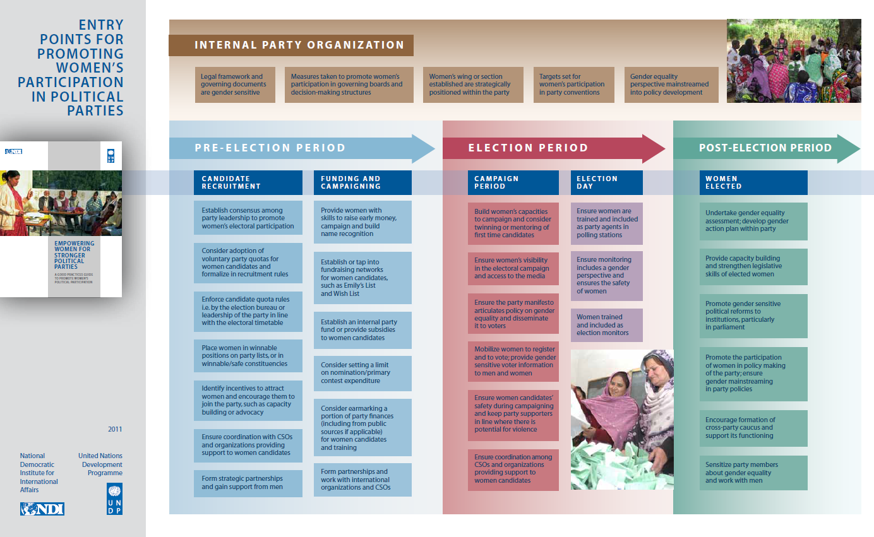

Annex 3: Draft UN Women Theory of Change: Women’s Political Participation & Leadership
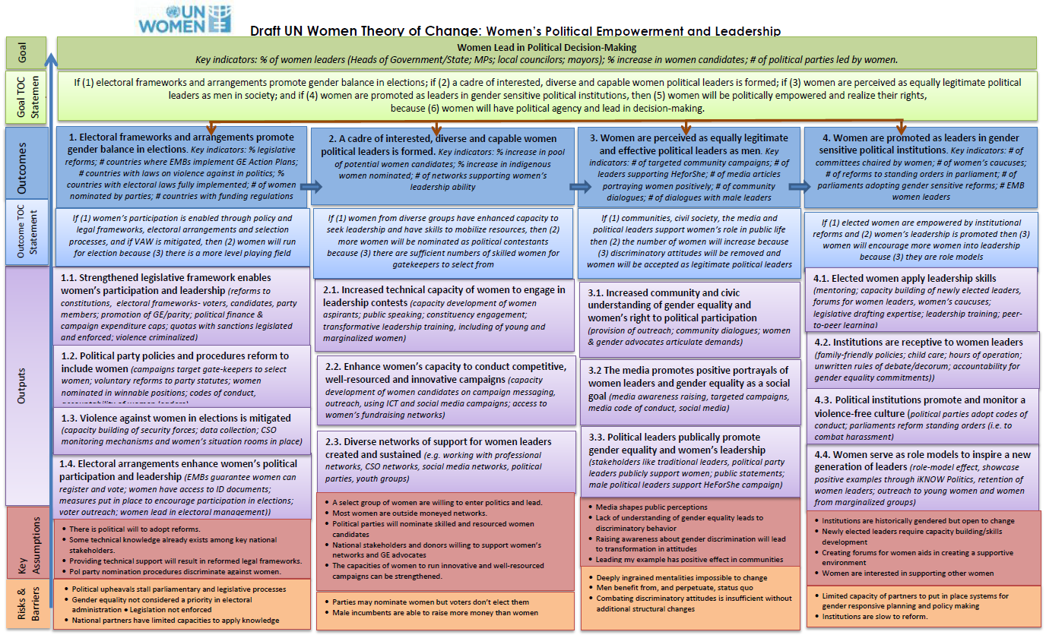

This Report was authored by Ms Mary Fairio from the PNG National Research Instutue, and Ms Charmaine Rodrigues, the facilitator of the Women Candidates Forum.
G. Kenneth, “Total Candidates for 2017’, Post Courier, 2 May 2017, http://postcourier.com.pg/total-candidates-2017/.
T. Wood, “Women candidate numbers up in PNG”, DevPolicy Blog, 15 June 2017, http://devpolicy.org/women-candidate-numbers-up-in-png-20170615/.
Rodrigues & Tuivanualevu (2016) Women and Leadership Roadmap: Synthesis Report, unpublished. Pacific Women: Suva.
https://www.surveymonkey.com/r/G93JN9T .
https://www.facebook.com/PNGWomeninLeadership/
http://www.pacwip.org/resources/uploads/attachments/documents/Survey%20Results%20-%20summary%20notes%20-%2018-8-17.docx
http://www.pacwip.org/resources/uploads/attachments/documents/2007%20Womens%20Election%20Diagnostic%20Report.pdf
http://www.pacwip.org/resources/uploads/attachments/documents/2012%20Womens%20Election%20Diagnostic.pdf
Article 21: The provisions of this Constitution that recognize rights of individuals (including corporations and associations) as well as those that confer powers or impose duties on public authorities, shall not be left without effect because of the lack of supporting, machinery or procedural laws, but the lack shall, as far as practicable, be supplied by the National Court (emphasis added).

